Our 140/160 4x4 trucks use the Wagner FD5997 & FD5998 that are no longer available. I believe the wheel cylinder kits are still available

I’ve been told by a reputable brake shop that the IH military guys have started using these wheel cylinders (WC8264/wc8265) on the front of their M3-H/L4 and M5-H/L6 trucks. Those trucks came originally with the Wagner FD5997 & FD5998 front wheel cylinders, just like our 140/160 4x4 trucks. I have not used these cylinders myself, but did buy a set and they’re really close, dimensionally.
These have a 1” & 1-3/8” bores, whereas our FD5997 & FD5998 have 1-1/8” & 1-3/8” bores. The angle that the hose comes out is different, but the rest of the dimensions are very similar.
Try at your own risk, but a reputable source told me this would work and they look workable to me.

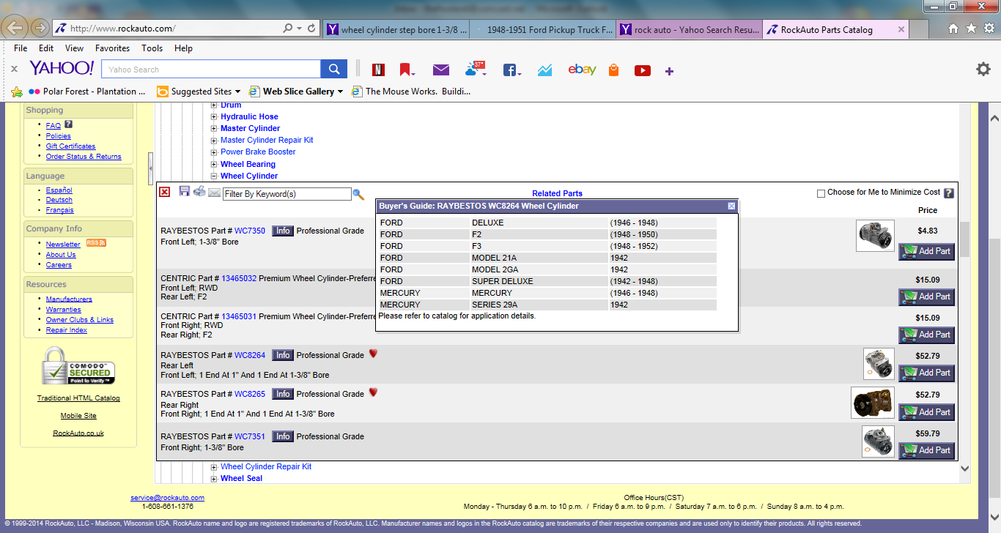
WC8264 Below
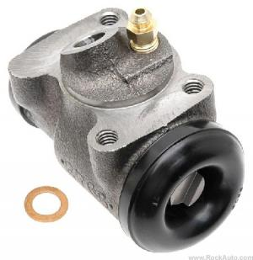
WC8265 Below
